
SOUTH EAST EDUCATION DIVISION EXAMINATIONS
2026 MALAWI SCHOOL CERTIFICATE OF EDUACTION MOCK EXAMINATION

PHYSICS
Provisional marking scheme
Paper II (40 Marks)
Section A (20 marks)
Question ONE
- Set up the apparatus as shown in the diagram.
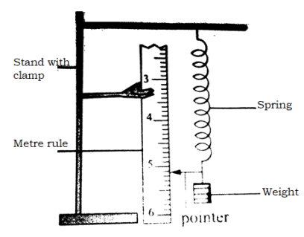
Diagram (1)
Labelling (1)
- Attach a spring of unstretched length to a strong clamp fixed on a retort stand. (1)
- Place a metre rule vertically beside the spring to measure its length. (1)
- Record the original (unstretched) length of the spring. (1)
- Suspend known weights one at a time on the spring. (1)
- Record the new length of the spring for each added weight. (1)
- Determine the extension by subtracting the original length from the stretched length. (1)
- Tabulate the results of force (weight) against extension. (1)
- Plot a graph of force against extension to verify that extension is directly proportional to force. (1)
Question two
- Suspend the electric bell inside an air-tight bell jar. (1)
- Switch on the bell, while there is some air in the bell jar. (1)
- Start the pump to take the air molecules out of the jar (1) as you listen to the change in the intensity of sound (1)
- Return the air to the bell-jar again by opening the stopper (1) slightly as you listen the change in sound. (1)
- When there is air in the jar the bell is heard ringing. (1)
- When the pump is switched on to remove the air, the sound dies down gradually and eventually not heard at all. (1)
- When air is allowed to return to the jar, the sound is heard once again. (1)
- This shows that sound can not travel in a vacuum. (1)
Question three
Description | Reading | Awarded mark
Weight of object V in air(N) | 3.0 | (1)
Weight of object V in water (N) | 2.6 | (1)
Initial volume of water (cm³) | 50(any) | (1)
Final volume of water (cm³) | 88 | (1)

(1)
(1)
- Volume of displaced water = volume of object
= 88cm³ – 50cm³ (this depends on the initial volume) (1)
= 38cm³ (1)
mass of displaced water
(1)
Weight of displaced water (1)
Question four
Object distance, u (cm) | Image distance, v (cm) | (u + v) (cm)
15 | 30 | 45
20 | 20 | 40
25 | 16.7 | 41.7
30 | 15 | 45
40 | 13.3 | 53.3
(4 marks)
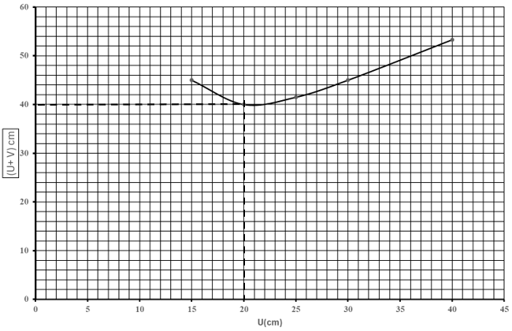
(4 marks)
- From the turning point, U= 20cm
Using 2f = 20cm (1)
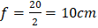 (1)

END OF PROVISIONAL MARKING KEY!
NB: This paper contains 4 printed pages

